1. Inception paragraph and use case names:
WWE is a global sports entertainment company that stages professional wrestling shows. Its core revenue loop is the live event: the company signs wrestlers, schedules events at venues, books matches and storylines that make fans want to watch, and then sells tickets to those events. Every event is also television content, so the same card earns money a second time through media rights and pay-per-view, and a third time through merchandise sold at the venue and online. Popular wrestlers and strong storylines drive attendance, which drives the next round of bookings.
Our ERP is a Java command-line system for WWE staff. It stores all records in text files, with no database, no GUI, and no login.
Use Case Names:
Sign Wrestler, Renew Contract, Release Wrestler, Promote to Main Roster
Create Live Event, Book Venue, Cancel Events
Schedule Live Broadcast for Events
Sell Tickets, Refund Ticket, Ticket admits to event
Record Injury, Clear Wrestler to Compete, View Medical Records
2. One use case per person, with name, actor, precondition, main success scenario, alternate flows:
Group Member: Oliver
Name: Talent Relations
Actors: Talent Management
Precondition: Talent has agreed to the terms of the contract.
Main Success Scenario: Talent manager selects Talent Relations from the department menu, then selects Sign Wrestler.
- System asks for the wrestler's legal name.
- Talent manager enters the legal name.
- System asks for the wrestler's stage name.
- Talent manager enters the stage name.
- System lists the brands (RAW, SMACKDOWN, NXT) as numbered choices.
- Talent manager picks a brand.
- System assigns the next wrestler ID, saves the wrestler with status ACTIVE to Wrestlers.txt, and displays the new wrestler record.
- Talent manager selects Create Contract and enters the new wrestler's ID.
- System finds the wrestler and displays who the contract is for.
- Talent manager enters the yearly salary, start date, and end date.
- System checks that the salary is a whole number above 0 and the end date is after the start date.
- System assigns the next contract ID, saves the contract linked to the wrestler's ID to Contracts.txt, and displays the new contract
Alternate flows:
- Legal name left blank: System asks for the legal name again.
- Stage name left blank: System asks for the stage name again.
- Invalid brand choice: System says "Invalid choice" and lists the brands again.
- Wrestler file cannot be written: System says the wrestler could not be saved. Nothing is saved, and the use case ends.
- No wrestler with that ID: System says no wrestler has that ID and returns to the Talent Relations menu.
- Start date left blank: System uses today's date.
- Date not in YYYY-MM-DD format: System asks for the date again.
- Salary is not a whole number above 0: System asks for the salary again. Commas are allowed, like 2,500,000.
- End date is not after the start date: System says the end date must be after the start date and asks again.
Group Member: Caleb
Name: Create Live Event
Actors: Live Events Coordinator (primary), Finance Manager (approves over-budget events)
Precondition: Coordinator has opened the Live Events menu.
Main Success Scenario: Coordinator selects Create Live Event.
- System displays the event form
- Coordinator enters the event name, type, brand, date, and city.
- System lists venues in that city that are available on that date and meet the minimum capacity for that event type.
- Coordinator selects a venue
- System places a tentative hold and shows the rental cost and capacity.
- Coordinator confirms the event.
- System checks that the brand has no other event on the same date.
- System checks that the estimated cost is within the budget for that event type.
- System saves the event as scheduled and notifies ticketing and talent relations.
- System displays a confirmation with the event ID.
Alternate flows:
2a. Date has already passed: System says so and asks for the date again.
3a. No venues available: System says no venue fits. Coordinator either changes the date or city and returns to step 3, or saves the event as a draft.
3b. Coordinator cancels: System saves nothing and returns to the menu.
4a. Venue not in the system: Coordinator adds a new venue record, then returns to step 3.
5a. Venue rejects the hold: Coordinator reports the rejection. System returns to step 3 with that venue removed from the list.
6a. Coordinator does not confirm: System releases the hold and saves nothing.
7a. Brand conflict: System warns that the brand already has an event that day. Coordinator changes the date and returns to step 3, or cancels, which releases the hold and saves nothing.
8a. Cost is over budget: System saves the event as pending approval and routes it to the finance manager. If approved, the event is scheduled and ticketing and talent relations are notified. If rejected, the event reverts to a draft and the venue is released.
Group Member: Jacob Nickel
Name: Schedule Live Video Match
Preconditions: The show, its network, and the show’s events are recorded in the system.
Main success scenario: A new live video match with status scheduled is saved, linked to its show and event
- Coordinator chooses to schedule a live video match.
- System displays the list of shows with their networks.
- Coordinator selects a show.
- System displays the show’s upcoming events.
- Coordinator selects an event and enters the broadcast start time.
- System verifies that the event date is in the future.
- System verifies that the event doesn’t already have a live video match.
- System verifies that no other live video match is scheduled on the show’s network at that date and time.
- System creates the live video match with status SCHEDULED, saves it, and displays a confirmation with its ID.
Alternate Flows:
- *a. Coordinator cancels at any time: nothing is saved; return to the menu.
- 3a. Show doesn’t exist: error; return to step 2.
- 4a. Show has no upcoming events: system says so; return to step 2.
- 6a. Event date has passed: rejected; return to step 4.
- 7a. Event already has a live video match: system shows it; return to step 4.
- 8a. Network slot taken: system shows the conflict and asks for a different time.
- 9a. Save fails: error; nothing is saved.
• Group Member: Shea Keister
• Name: Add Injury
• Actors: Medical Coordinator / Personnel
• Precondition: a valid Wrestler ID exists in Data/Wrestlers.txt.
• Main Success Scenario:
1. Personnel selects Add Injury.
2. System prompts for the Wrestler ID.
3. Personnel enters the Wrestler ID.
4. System confirms the wrestler's identity and displays their current name and status.
5. System prompts for injury details (Description and Start Date).
6. Personnel enters the description and a valid start date.
7. System instantiates a new ongoing injury entry (setting its active status to true and end date to null).
8. System appends the new record to medical_records.csv.
9. System automatically changes the wrestler's status to INJURED and medicalClearance to false inside Data/Wrestlers.txt.
10. System displays a confirmation screen showing that the wrestler has been successfully benched.
• Alternate Flows:
• 3a. Invalid Wrestler ID: System states that no wrestler exists with that ID. Personnel is prompted to re-enter the ID or return to the main menu.
• 6a. Blank description: System warns that description cannot be empty. Personnel is re-prompted.
• 6b. Invalid date format: System flags a bad date format. Personnel is re-prompted to use YYYY-MM-DD.
• Group Member: Shea Keister
• Name: Clear Injury
• Actors: Medical Coordinator / Personnel
• Precondition: Personnel is logged in, a valid Wrestler ID exists, and that wrestler has at least one active injury on record.
• Main Success Scenario:
1. Personnel selects Clear Injury.
2. System prompts for the Wrestler ID.
3. Personnel enters the Wrestler ID.
4. System searches the master medical cache and lists all currently active injuries for that wrestler with their index numbers.
5. Personnel selects the index number of the injury that is healed.
6. System flips that injury's active status flag to false and automatically logs the current date (LocalDate.now()) as the clearance endDate.
7. System rewrites the data back to medical_records.csv.
8. System checks the wrestler's remaining history. If no other active injuries exist, it updates the wrestler's status back to ACTIVE and medicalClearance to true inside Data/Wrestlers.txt.
9. System displays a confirmation showing the cleared injury details and the wrestler's updated readiness status.
• Alternate Flows:
• 4a. No active injuries found: System informs personnel that this wrestler is already fully cleared and has no ongoing injuries to resolve. Use case terminates.
• 5a. Invalid index entered: System flags that the number chosen does not map to any active injury. Personnel is re-prompted to pick a number from the list.
• Group Member: Shea Keister
• Name: View Medical Records
• Actors: Medical Coordinator / Executive Management
• Precondition: Personnel is logged in, and medical_records.csv exists.
• Main Success Scenario:
1. Personnel selects View Medical Records.
2. System prompts to enter a specific Wrestler ID, or enter 0 to look up the entire promotion's directory.
3. Personnel enters a specific valid Wrestler ID.
4. System pulls up that wrestler's file, showing their full name, overall availability status, and a chronological list of every injury they have ever sustained (including past recovered items and start/end dates).
5. System keeps the list open on screen until personnel presses enter to return to the menu.
• Alternate Flows:
• 3a. Directory Lookup (0 chosen): Personnel enters 0 instead of a specific ID. System parses the entire medical_records.csv cache and outputs a complete, grouped list of all registered wrestler IDs alongside their chronological injury rows.
• 4a. No medical history exists for ID: System flags that the Wrestler ID is valid but they have a completely clean medical slate with zero historical entries.
• 4b. Empty Master Directory: If 0 is chosen but no records have ever been written to disk, the system displays a text notification stating the directory database is currently empty.
4. Domain model for the iteration
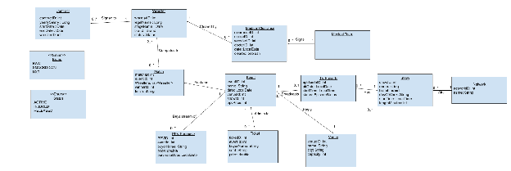
5. Partial communication diagrams for the use case
Talent relations:
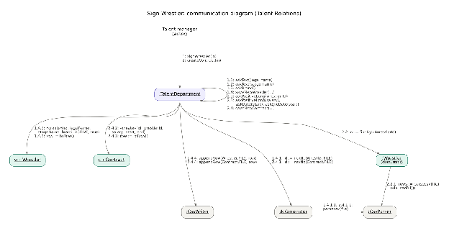
Live Events:
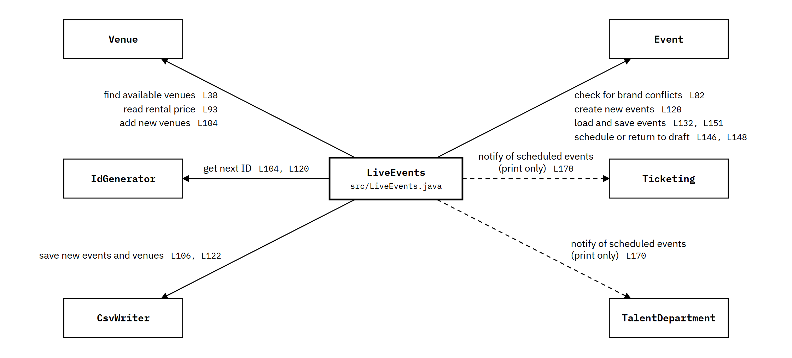
Schedule Live Broadcast:
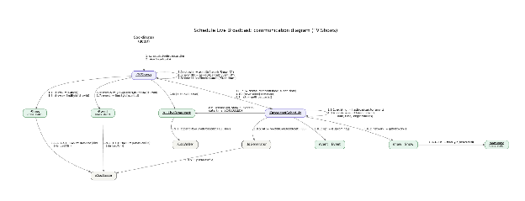
Add Injury:
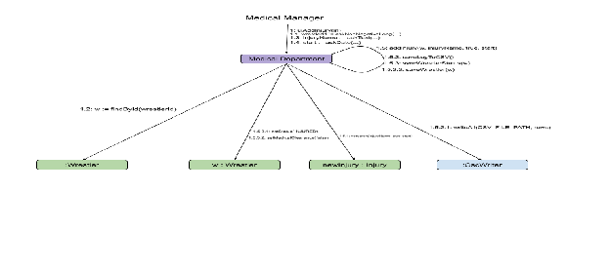
6. Partial class diagrams
Talent Relations:
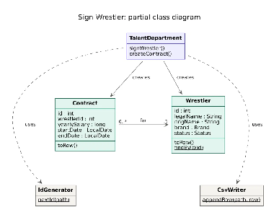
Live Events:
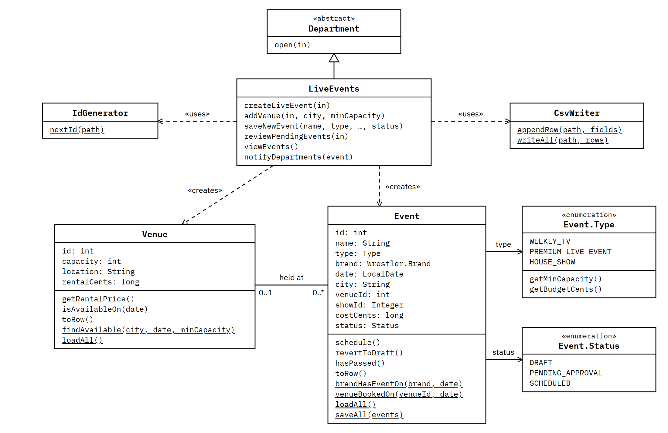
Live Broadcast:
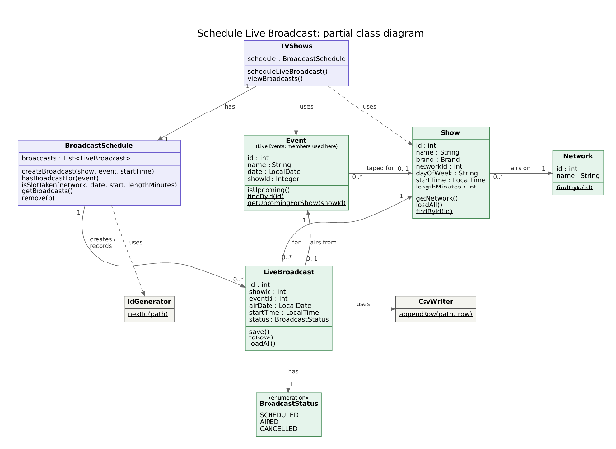
Medical Department:
Add Injury:
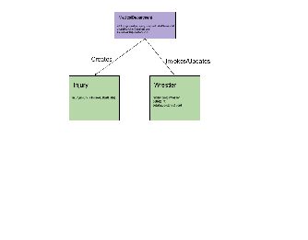
7. Interface list
Class, Operation, Returns, Static
Talent Relations interface list:
- TalentRelations,signWrestler(legalName,ringName,brand),void,No
- TalentRelations,createContract(wrestlerId,salary,start,end),void,No
- TalentRelations,renewContract(contractId,salary,start,end),void,No
- TalentRelations,promoteToMainRoster(wrestlerId,brand),void,No
- Wrestler,"«create»Wrestler(id,legalName,ringName,brand,status)",Wrestler,No
- Wrestler,toRow(),List,No
- Wrestler,getBrand(),Brand,No
- Wrestler,getStatus(),Status,No
- Wrestler,setBrand(brand),void,No
- Wrestler,findById(id),Wrestler,Yes
- Wrestler,loadAll(),ListOfWrestler,Yes
- Wrestler,fromRow(row),Wrestler,Yes
- Wrestler,saveAll(wrestlers),void,Yes
- Contract,"«create»Contract(id,wrestlerId,salary,start,end)",Contract,No
- Contract,toRow(),List,No
- Contract,getWrestlerId(),int,No
- Contract,getYearlySalary(),long,No
- Contract,getEndDate(),LocalDate,No
- Contract,isActiveOn(date),boolean,No
- Contract,findById(id),Contract,Yes
- Contract,loadAll(),ListOfContract,Yes
- Contract,fromRow(row),Contract,Yes
- Contract,"hasActiveContract(wrestlerId,date)",boolean,Yes
Helper Classes interface list:
- IdGenerator,nextId(path),int,Yes
- CsvParser,parsecsv(file),ArrayListOfArrayListOfObject,Yes
- CsvWriter,"appendRow(path,fields)",void,Yes
- CsvWriter,"writeAll(path,rows)",void,Yes
Live Events interface list:
- LiveEvents,«create»LiveEvents(),LiveEvents,No
- LiveEvents,getUseCases(),ListOfString,No
- LiveEvents,"runUseCase(choice,in)",void,No
- LiveEvents,createLiveEvent(in),void,No
- LiveEvents,"addVenue(in,city,minCapacity)",void,No
- LiveEvents,"saveNewEvent(name,type,brand,date,city,venueId,cost,status)",void,No
- LiveEvents,reviewPendingEvents(in),void,No
- LiveEvents,viewEvents(),void,No
- LiveEvents,notifyDepartments(event),void,No
- Event,"«create»Event(id,name,type,brand,date,city,venueId,showId,costCents,status)",Event,No
- Event,getId(),int,No
- Event,getName(),String,No
- Event,getDate(),LocalDate,No
- Event,getShowId(),Integer,No
- Event,getStatus(),Status,No
- Event,isUpcoming(),boolean,No
- Event,hasPassed(),boolean,No
- Event,schedule(),void,No
- Event,revertToDraft(),void,No
- Event,toRow(),List,No
- Event,toString(),String,No
- Event,"brandHasEventOn(brand,date)",boolean,Yes
- Event,"venueBookedOn(venueId,date)",boolean,Yes
- Event,getUpcomingForShow(showId),ListOfEvent,Yes
- Event,findById(id),Event,Yes
- Event,loadAll(),ListOfEvent,Yes
- Event,saveAll(events),void,Yes
- Event,fromRow(row),Event,Yes
- Event.Type,getMinCapacity(),int,No
- Event.Type,getBudgetCents(),long,No
- Venue,"«create»Venue(id,capacity,location,rentalCents)",Venue,No
- Venue,getId(),int,No
- Venue,getCapacity(),int,No
- Venue,getLocation(),String,No
- Venue,getRentalPrice(),long,No
- Venue,isAvailableOn(date),boolean,No
- Venue,toRow(),List,No
- Venue,toString(),String,No
- Venue,"findAvailable(city,date,minCapacity)",ListOfVenue,Yes
- Venue,dollars(cents),String,Yes
- Venue,saveAll(venues),void,Yes
- Venue,loadAll(),ListOfVenue,Yes
- Venue,fromRow(row),Venue,Yes
TV Shows interface list:
- TVShows,”scheduleLiveBroadcast(showId,eventId,startTime)”,void,No
- TVShows,viewBroadcasts(),void,No
- BroadcastSchedule,«create»BroadcastSchedule(),BroadcastSchedule,No
- BroadcastSchedule,”createBroadcast(show,event,startTime)”,LiveBroadcast,No
- BroadcastSchedule,hasBroadcastFor(event),LiveBroadcast,No
- BroadcastSchedule,”isSlotTaken(network,date,start,lengthMinutes)”,LiveBroadcast,No
- BroadcastSchedule,getBroadcasts(),ListOfLiveBroadcast,No
- BroadcastSchedule,remove(broadcast),void,No
- LiveBroadcast,”«create»LiveBroadcast(id,showId,eventId,airDate,startTime,status)”,LiveBroadcast,No
- LiveBroadcast,save(),void,No
- LiveBroadcast,toRow(),List,No
- LiveBroadcast,getShowId(),int,No
- LiveBroadcast,getEventId(),int,No
- LiveBroadcast,getAirDate(),LocalDate,No
- LiveBroadcast,getStartTime(),LocalTime,No
- LiveBroadcast,getStatus(),BroadcastStatus,No
- LiveBroadcast,loadAll(),ListOfLiveBroadcast,Yes
- LiveBroadcast,fromRow(row),LiveBroadcast,Yes
- Show,”«create»Show(id,name,brand,networkId,dayOfWeek,startTime,lengthMinutes)”,Show,No
- Show,getNetwork(),Network,No
- Show,getNetworkId(),int,No
- Show,getLengthMinutes(),int,No
- Show,toRow(),List,No
- Show,findById(id),Show,Yes
- Show,loadAll(),ListOfShow,Yes
- Show,fromRow(row),Show,Yes
- Network,”«create»Network(id,name)”,Network,No
- Network,getName(),String,No
- Network,toRow(),List,No
- Network,findById(id),Network,Yes
- Network,loadAll(),ListOfNetwork,Yes
- Network,fromRow(row),Network,Yes
Medical Department interface list:
- MedicalDepartment,getInstance(),MedicalDepartment,Yes
- MedicalDepartment,addInjury(wrestler,injury,isInjured,startDate),void,Yes
- MedicalDepartment,clearInjury(wrestler,injuryIndex),void,Yes
- MedicalDepartment,syncWrestlerStatus(wrestler),void,Yes
- MedicalDepartment,getInjuriesByWrestlerId(wrestlerId),List,Yes
- MedicalDepartment,getAllMedicalRecords(),Map,Yes
- MedicalDepartment.Injury,"«create»Injury(injury,isInjured,startDate)",Injury,No
- MedicalDepartment.Injury,getInjury(),String,No
- MedicalDepartment.Injury,isInjured(),boolean,No
- MedicalDepartment.Injury,setInjured(injured),void,No
- MedicalDepartment.Injury,getStartDate(),LocalDate,No
- MedicalDepartment.Injury,getEndDate(),LocalDate,No
- MedicalDepartment.Injury,setEndDate(endDate),void,No
- MedicalDepartment.Injury,toString(),String,No

